**ASSIGNMENT-7.1**

Create a sample dataset and implement the below Pig commands on the same dataset.

1. 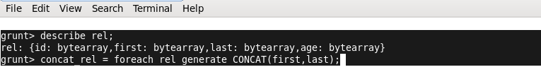**Concat:**

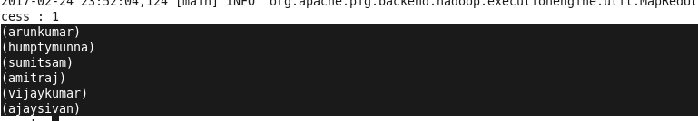**OUTPUT:**

1. **C:\Users\RMK\Desktop\tokenize.pngTokenize:**

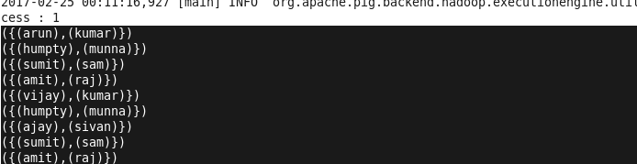**OUTPUT:**

1. **Sum:**

C:\Users\RMK\Desktop\sum.png

**OUTPUT:**

1. **Min:**



**OUTPUT:**

C:\Users\RMK\Desktop\min out.png

1. **Max**

**OUTPUT:**



1. **Limit:**



**OUTPUT:**

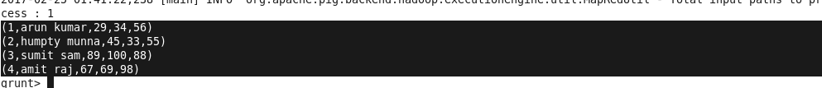

1. **Store:**



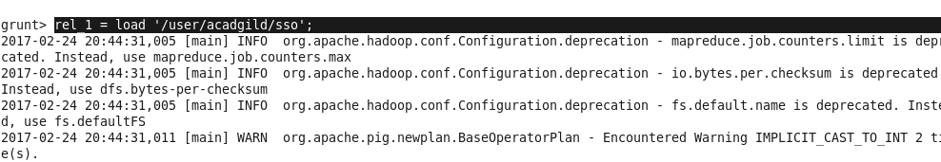**OUTPUT**

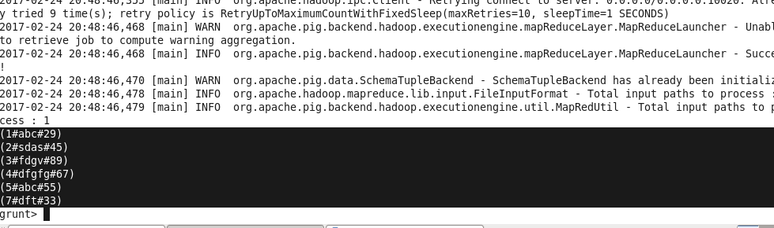

1. **Distinct:**

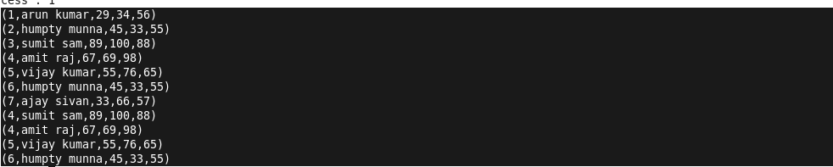



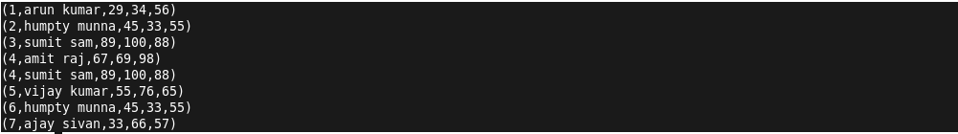**OUTPUT**

1. **Flatten:**

C:\Users\RMK\Desktop\gr.png



**OUTPUT**

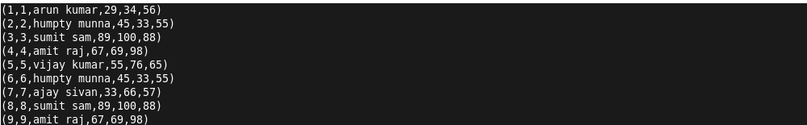

1. **IsEmpty:**

C:\Users\RMK\Desktop\cogroup.png

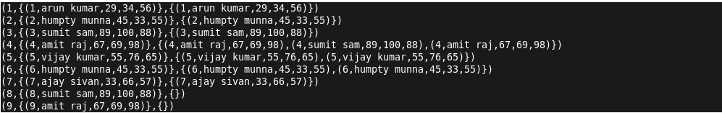

C:\Users\RMK\Desktop\isem.png

**OUTPUT**

